

Invitation to Quote
for Door Replacement and Partitioning at Friars Mill

Date: 4 January 2023

East Midlands Chamber (Derbyshire, Nottinghamshire, Leicestershire)
Commerce House
Millennium Way
Chesterfield
Derbyshire
S41 8ND

www.emc-dnl.co.uk
0333 320 0333

Contents
1. INTRODUCTION 1
2. JOB SPECIFICATION 1
3. EXISTING APERTURE DIMENSIONS 2
4. OTHER CONSIDERATIONS 2
5. QUOTATION 3
6. TENDER PROCESS 3
7. INSTRUCTIONS TO TENDERER 5
8. TENDER EXCLUSIONS 5
ANNEX A - STANDARD DETAILS QUESTIONNAIRE: 7
APPENDIX 1 – LAYOUT 10
APPENDIX 2 – PHOTOS OF EXISTING DOOR AND APPATURE 11

1. INTRODUCTION

We are seeking quotations from fully subscribed members of East Midlands Chamber for the removal of the Boiler House sliding door and replacement with a double door at Friars Mill in Leicester.

Friars Mill is a managed workspace campus on Bath Lane, operated by East Midlands Chamber on behalf of Leicester City Council which owns the site

1.1 Site Address

Friars Mill
Bath Lane
Leicester
LE3 5BJ

1.2 Head Office and Invoice Address

East Midlands Chamber (Derbyshire, Nottinghamshire, Leicestershire)
Commerce House
Millennium Way
Dunston Road
Chesterfield
S41 8UD

1.3 Narrative

Friars Mill hosts 12 tenant businesses employing around 200 staff across 15 offices in five different buildings. The main building on site, also known as Friars Mill, is home to four meeting rooms as well as reception facilities for the whole site.

The reception area has recently been refurbished to provide a dedicated space for staff to work from. Currently, a large sliding door is used to close the void between reception and the Boiler House meeting room. Due to its design and lack of frame, the sliding door provides neither heat or sound insulation, nor an element of smoke suppression. In addition, the door’s weight makes opening difficult for less able users.

An inward opening set of double doors and infill of remaining space to fire regulation standards will remove the issues and make both spaces more comfortable for users.

2. JOB SPECIFICATION

2.1 Removal of the existing door

Removal of existing suspended timber sliding door and wall mounted timber pelmet with rail. The maglock and associated wiring are redundant but can be left in situ.

2.2 Replacement door

- Inward opening double swing doors to fit existing aperture height.
- Minimum 1050mm wide
- Lockable from reception side with thumb turn on Boiler House side for ease of exit.
- FD30 rated.
- Partially glazed or sight panels.
- Either timber or toughened glass.
2.3 Aperture infill/partitioning

- Either FD30 rated timber or obscured toughened glass to suit

2.4 Installation

Door and partition to be installed at Boiler House end of existing aperture.

2.5 Disposal

All waste materials to be removed from site for re-use or recycling where practical.

2.6 Timing

Work can be completed during standard opening hours.

3. EXISTING APERTURE DIMENSIONS

3.1 Height

2110mm

3.2 Width

2400mm

3.3 Depth

485mm

4. OTHER CONSIDERATIONS

4.1 Layout

Please refer to Appendix 1.

4.2 Ceiling height

4.2 meters at highest point. 3.7 meters to full-length cable tray in reception.

4.3 Fire systems

Three smoke and heat detectors mounted above the cable tray in reception. The Boiler House is served by an aspiration system. Consideration should be given to false alarms triggered by dust. Two fire exit doors open from reception.

4.4 Walls

Uncoated brick.

4.5 Welfare

RAMS and relevant insurance certificates will be required from the successful bidder prior to work commencing. A site induction will be provided on on the first day of work. WCs and kitchen facilities will be available throughout. Parking spaces will also be provided close to the front door.

5. QUOTATION

5.1 Submission deadline

Friday 27 January 2023 at 12pm.

5.2 Submission address

Procurement@emc-dnl.co.uk

5.3 Site visit dates

By appointment only between 10 and 20 Januuary 2023.

5.4 Project manager

Tom Munro
Managed Workspace Manager
t) 07854 065 948
e) tom.munro@emc-dnl.co.uk

5.5 Accompanying information

Appendix 2 includes three photographs of existing door and appature.

6. TENDER PROCESS

An electronic written submission should be submitted that cover the following specific requirements.

Tenders must include:

- A proposal providing details of your relevant experience to meet the requirements of this tender
- Completion of the Standard Details Questionnaire
- An itemised breakdown of costs (excluding VAT)

The tender process is in one stage and will be assessed by an internal evaluation panel.

- Stage one: Proposal (60 points)

Proposals will be scored and weighted as detailed in the scoring matrix below.

6.1 PROPOSAL (60 POINTS SCORING VALUE):

6.1.1 Solution: (weighting 4)

How well has the supplier understood and addressed the Chamber’s requirements and the project definition set out in this invitation to tender in regard to:

Quality and clarity of proposal
Addressing the tender (‘essentials’)
Usability
Sustainability

6.1.2 Confidence: (weighting 4)

Is the supplier capable of achieving the Chambers needs and objectives?

Stability of supplier and size of their team
Technical ability to meet project essentials
Ongoing support and care
Sector expertise
Wider services offered, customer care, and control over spend

6.1.3 Value: (weighting 3)

Is the supplier’s price competitive and/or do their proposals provide best value/fit?

6.1.4 Risk: (weighting 1)

Has the supplier’s submission identified the key risks presented by their proposal?

6.1.5 Presentation (weighting 2)

Is the submission comprehensive and well presented?

6.2 Evaluation Scoring Process

The scoring panel will use the following framework to weight each final score:

- Scoring Principles
Required Data
Required Data |  | All questions must be answered unless there is an acceptable reason for its omission. The data will be scored as pass or fail
Pass |  | The information has been assessed and judged to be acceptable
Fail |  | No information evidence has been provided. The standard of the information is unacceptable or does not comply with the minimum acceptable standard
Scored (0 / 1 / 2 / 3 / 4 / 5)
0 | Unacceptable |  | The information is either omitted or fundamentally unacceptable to the Chamber.
1 | Poor |  | The information submitted has some omissions or demonstrates only limited technical, ability and/or capacity.
2 | Satisfactory |  | The information submitted just meets the Chamber’s  expectations in demonstrating technical experience, ability  and/or capacity to deliver the services. There are significant  reservations, but not sufficient to warrant rejection.
3 | Good |  | The information submitted meets the Chamber’s expectations in  demonstrating technical experience, ability and/or capacity to  deliver the services.
4 | High Standard |  | The information submitted meets the Chamber’s expectations  and provides strong evidence of technical experience, ability  and/or capacity to deliver a quality service.
5 | Exceeding all expectations |  | The information exceeds all expectations and provides strong evidence of technical experience, ability and/or capacity to deliver a quality service.

7. INSTRUCTIONS TO TENDERER

Email a copy of your proposal, completed Standard Details Questionnaire and any supplementary information to procurement@emc-dnl.co.uk and copy in tom.munro@emc-dnl.co.uk with the subject line ‘Quote – Boiler House door’.. Tenders submitted after the stipulated time and date will be rejected.

Tenderers should note that if a bid is fundamentally unacceptable on a key issue, regardless of its other merits, the bid will be rejected.

7.1 Timetable for Submission

Issue of formal ITT to selected suppliers: | 4 January 2023
Tender return deadline: | 27 January 2023
Feedback to applicants: | 1 February 2023
Contract initiation meeting: | TBC

7.2 Tender Questions

If you require further information about the requirements of the contract or the tendering procedures, please email procurement@emc-dnl.co.uk and copy in tom.munro@emc-dnl.co.uk No questions will be answered that provide a competitive advantage to any party tendering.

Should questions arise during the tendering period which in our judgement are significant, we will inform all providers to explain the nature of the question and our formal reply. Providers should take that reply into consideration when preparing their own proposals, and we will evaluate proposals on the assumption that they have done so.

8. TENDER EXCLUSIONS

It must be recognised that the Chamber reserves the right to withdraw this tender document and all funding contained within it without notice:

- No tender will be considered for acceptance if the potential provider has indulged or attempted to indulge in any corrupt practice or canvassed the tender with a member of staff employed by the Chamber

- If the successful provider has indulged or attempted to indulge in such practices and the tender is accepted, then grounds shall exist for the termination of the contract and the claiming of damages from the successful provider

- It is unlikely that any tender will be accepted which (a) is incomplete or inaccurately or inadequately completed or which purports to impose conditions other than those provided in the contract documents and (b) is delivered out of time or in a manner other than specified in the specification

In submitting a tender against this contract, the potential provider confirms that he has not fixed or adjusted the amount of the tender by or under or in accordance with any agreement or arrangement with any other person.

The potential provider also certifies that at no time, before or following the submission of the tender, has the tenderer carried out any of the following acts:

- Entering into any agreement or arrangement with any person that he shall refrain from tendering or as to the amount of any tender to be submitted

- Offering or paying or giving or agreeing to give any sum of money or valuable consideration directly or indirectly to any person for doing or having done or causing or having caused to be done in relation to any other tender or proposed tender for the said work any act or thing of the sort described above. The context of this clause the word ’person’ includes any persons and anybody or association, corporate or unincorporated, and ‘any agreement’ includes any such transaction, formal or informal, and whether legally binding or not.

ANNEX A - STANDARD DETAILS QUESTIONNAIRE:

Please complete the following standard details questionnaire. If the question does not apply, please write N/A; if you don’t know the answer, please write N/K.

Completing and returning this documentation does not in any way guarantee any work.

Section 1: BASIC DETAILS OF YOUR ORGANISATION
1.1 | Name of the organisation:
1.2 | Contact name:
1.3 | Job Title:
1.5 | Company address and post code:
1.6 | Telephone number:
1.7 | E-Mail address:
1.9 | Website address:
1.10 | Company Registration number (if applicable):
1.10 | Charities or Housing Association or other Registration number (if applicable):
1.11 | Date of Incorporation or Registration:
1.12 | Registered address if different from the above
1.13 | VAT Registration number:
1.14 | Is your organisation: | i) A public limited company? |  | Yes / No
 |  | ii) A limited company? |  | Yes / No
 |  | iii) a partnership |  | Yes / No
 |  | iv) a sole trader |  | Yes / No
 |  | v) other (please specify) |  | Yes / No
1.15 | Name of (ultimate) parent company (if this applies):
1.16 | Companies House Registration number of parent company (if applicable):
1.17 | How many staff does your organisation employ? (If you are a sole trader, please say so)
Section 2: FINANCIAL INFORMATION
2.1 | Please provide details of your turnover and net profit for the last two financial years:
 | Year:  Year: | Turnover:  Turnover: | Net profit:  Net profit:
2.2 | Can you provide copies of your audited annual accounts for the last two years |  | Yes/No
2.3 | Has your organisation met the terms of its banking facilities/loan agreements (if any) |  | Yes/No
2.4 | If ‘No’ what were the reasons, and what has been done to put things right?
2.5 | Has your organisation met all its obligations to pay its creditors and staff during the past year? |  | Yes/No
2.6 | If ‘No’ please explain why not.
Section 3: REFERENCES
Please provide details of two recent contracts that are relevant to this tender.
 |  | Reference 1 |  | Reference 2
3.1 | Name of customer:
3.2 | Contact name and phone number:
3.3 | Contract dates:
3.4 | Contract value:
3.5 | Website address
3.6 | Brief details about the service you provided:
3.7 | Have you had any contracts terminated for poor performance in the last three years, or any contracts where damages have been claimed by the contractor? |  |  | Yes / No
3.8 | If ‘Yes’, please give details:
Section 4: INSURANCE
Please provide details of your current insurance cover: |  |  |  | Value
5.1 | Employer’s Liability: |  |  | £
5.2 | Public Liability: |  |  | £
5.3 | Professional Indemnity: |  |  | £
5.4 | Other (please provide details): |  |  | £
Section 5: POLICIES
5.1 | Does your organisation have a written health and safety at work policy? |  |  | Yes / No
5.2 | Does your organisation have a health and safety at work system*? |  |  | Yes / No
5.3 | Does your organisation have a written equal opportunities policy covering Race, Sexual Orientation, Religion and Belief, Disability and Age, to avoid discrimination? |  |  | Yes / No
5.4 | If ‘No’, to either of the above please explain why:
5.5 | Does your organisation hold a recognised quality management certification for example BS/EN/ISO 9000 or equivalent? |  |  | Yes / No
5.6 | If not, do you/your organisation have a quality management system? |  |  | Yes / No
5.7 | Does your organisation have an environmental management system? |  |  | Yes/No
5.8 | If ‘No’, to the above quality systems please explain why:
Section 6: PROFESSIONAL AND BUSINESS STANDING
Do any of the following apply to you/your organisation, or to any director(s) / partners / proprietor(s)?
6.1 | Is in a state of bankruptcy, insolvency, compulsory winding up, receivership, composition with creditors, or subject to relevant proceedings |  |  | Yes / No
6.2 | Has been convicted of a criminal offence related to business or professional conduct |  |  | Yes / No
6.3 | Has committed an act of grave misconduct, in the course, of business |  |  | Yes / No
6.4 | Has not fulfilled obligations related to payment of social security contributions |  |  | Yes / No
6.5 | Has not fulfilled obligations related to payment of taxes |  |  | Yes / No
6.6 | Is guilty of serious misrepresentation in supplying information |  |  | Yes / No
6.7 | Is not in possession of relevant licences or membership of an appropriate organisation where required by law |  |  | Yes / No
6.8 | If the answer to any of these is ‘Yes’ please give brief details below, including what has been done to put things right.
Section 7: DECLARATIONS OF INTEREST
7.1 | Please identify if any of your staff personnel has been employed by the Chamber and/or related to any member of staff employed by the Chamber? If so, please provide further details?
Section 8: SIGNED DECLARATION
I declare that to the best of my knowledge the answers submitted in this document (and any supporting information) are correct. I understand that the information will be used in the evaluation process to assess my suitability to provide the services described.
(Electronic signatures or typed names are acceptable. In the event that your organisation is successful you will be required to resign this form with an original signature)
FORM COMPLETED BY:
8.1 | Name:
8.2 | Position:
8.3 | Date:
8.4 | Tel number:
8.5 | Signature:

APPENDIX 1 – LAYOUT
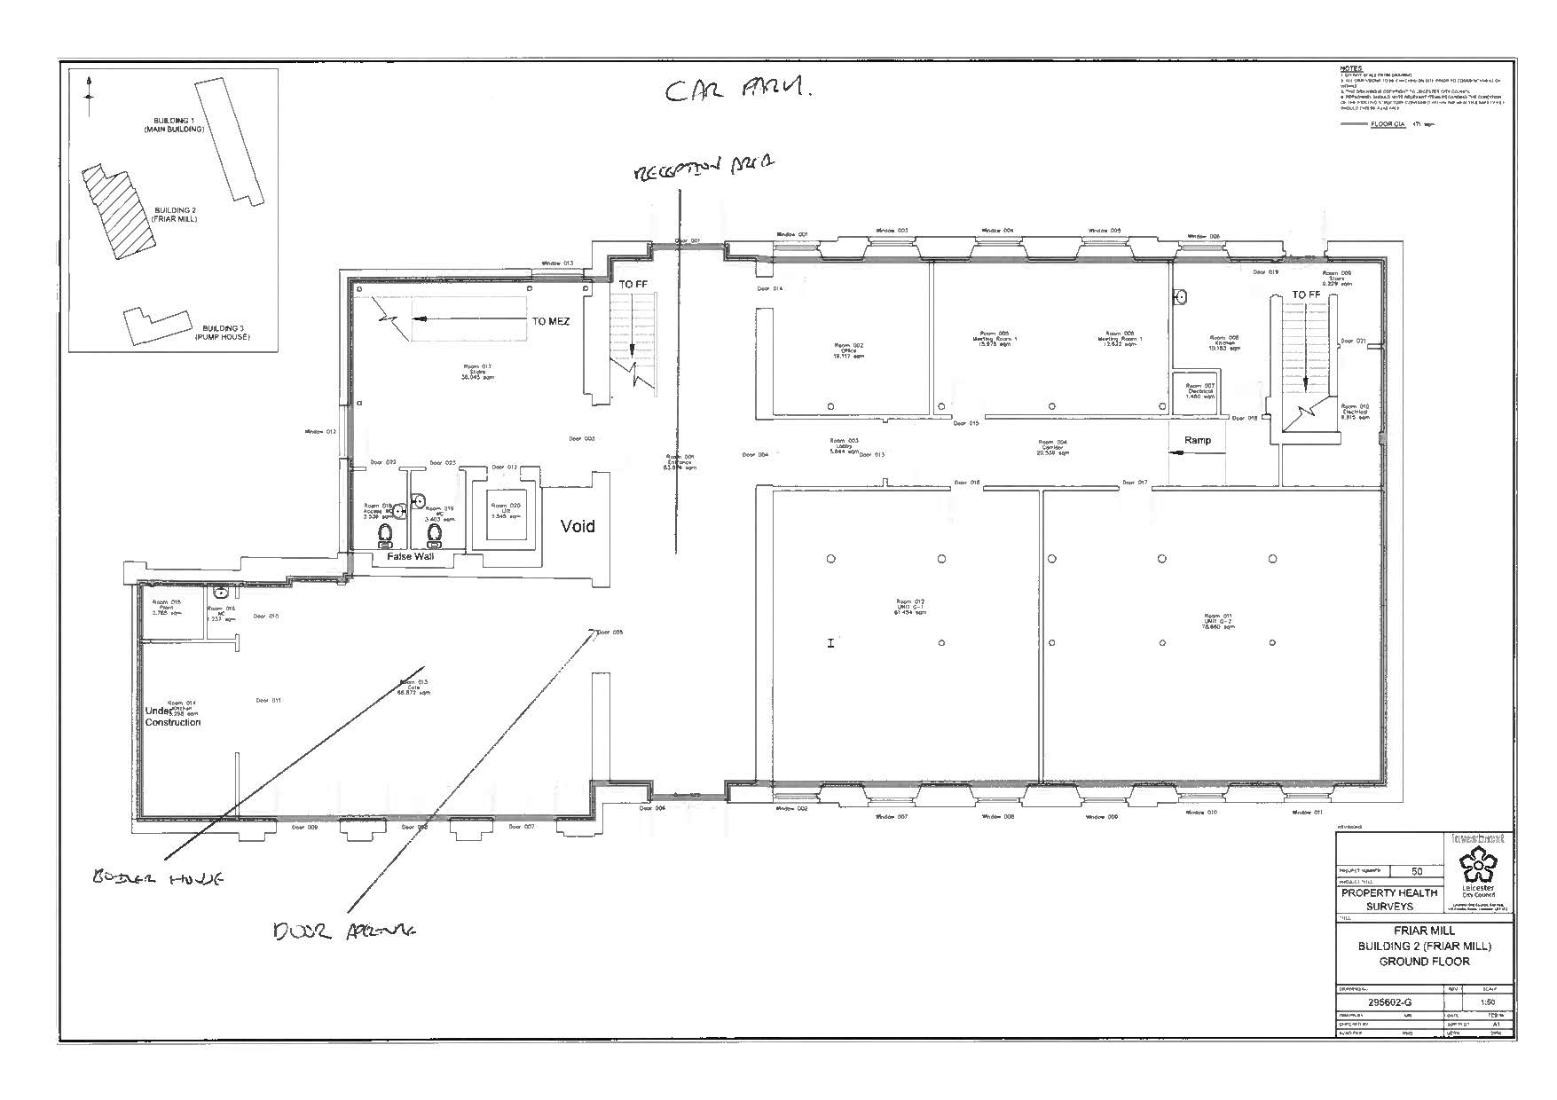

APPENDIX 2 – PHOTOS OF EXISTING DOOR AND APPATURE

